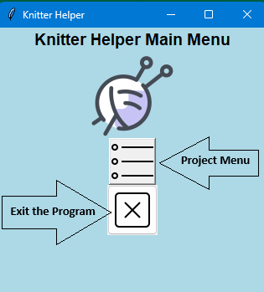

Welcome to the main menu screen. Here you will have the option to enter the project menu or exit the program.

In the project menu window, you will eventually be able to see a display of your projects in a list as the text file is populated. To add a new project, click the topmost button. To return to the main menu, use the middle button and you can exit the program entirely by clicking the “X” button.

This is the add new project menu accessed by choosing the topmost button on the project menu window.

1. Enter the project name. This can be anything that will help you remember the project like “Jenn’s blue cardigan.”
2. In this box you will enter the project type such as socks, sweaters, scarves, etc. I’ll enter “Sweater.”
3. Now you will enter the yarn weight. This is the thickness of the yarn. Think of a category or type of yarn. Let's enter “Aran.”
4. Finally, to track the size of the needle used, it goes into this entry box. I’ll assume I’m using “US 8.”

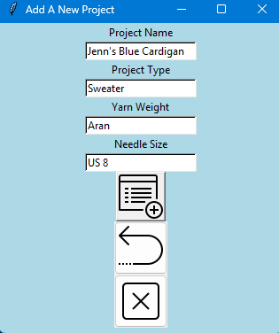

To save this to the file, choose the save button and the entry boxes will be cleared for the next project entry. Attempting to enter a project with blank fields will result in errors. A successful save will be displayed at the bottom if it is saved smoothly to the text file.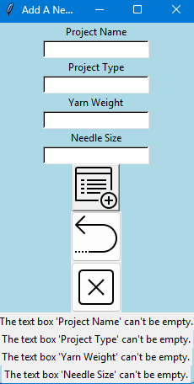

Returning to the project menu window will show a list of the current projects saved to the file. It will also print-out in the Python shell.

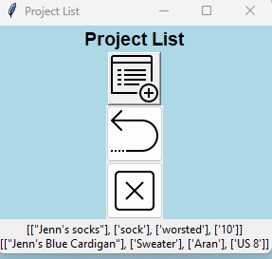

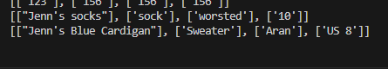

Return to the project menu will take you back to the previous screen and the “X” will close out the program.